Lab Title: Lab 7: Security Misconfiguration

• Assignment Title: Lab 7: Security Misconfiguration
• Student Name: Bashir Adam
• Student ID: 2025/FWSD/11509
• Course Name: BVWS103– OWASP-Top-10-Vulnerabilities-Exploitationentials
• Instructor Name: Aminu Idris
• Date of Submission: 02 FEB, 2026
• Version: Version 2.7.0

LAB OVERVIEW/OBJECTIVE

Objective:
In this lab, you will:
- Understand what Security Misconfiguration vulnerabilities are.
- Identify common security misconfigurations in web applications.
- Mitigate security misconfigurations through proper configurations and hardening.

Task 1: Exploit Security Misconfiguration

I first creating a folder named Lab 7 and inside the folder i created three file which are index.php, .htaccess and config.php
this is the index.php
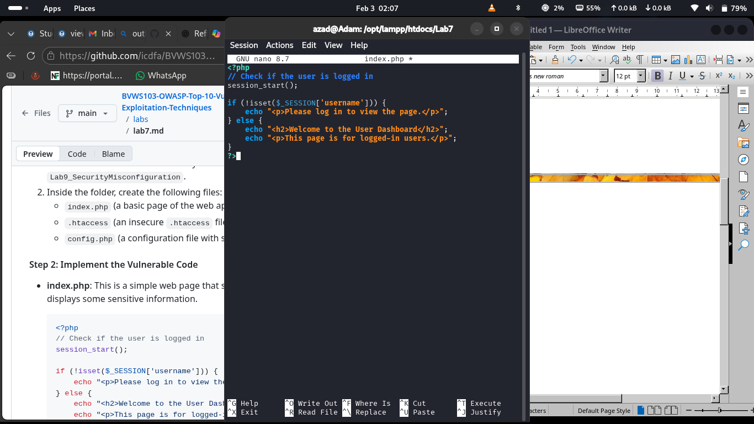

and this is the .htaccess file
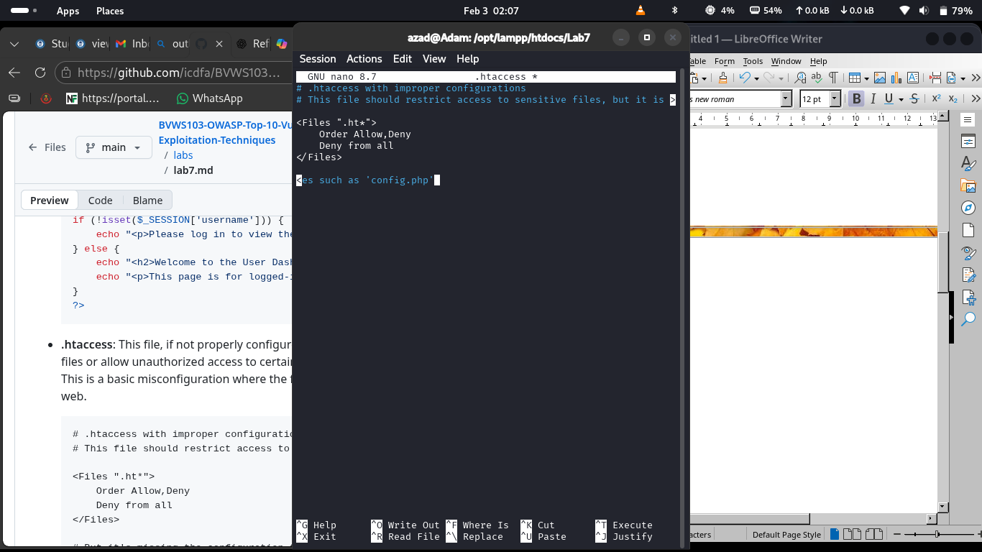

while this is the confige.php file
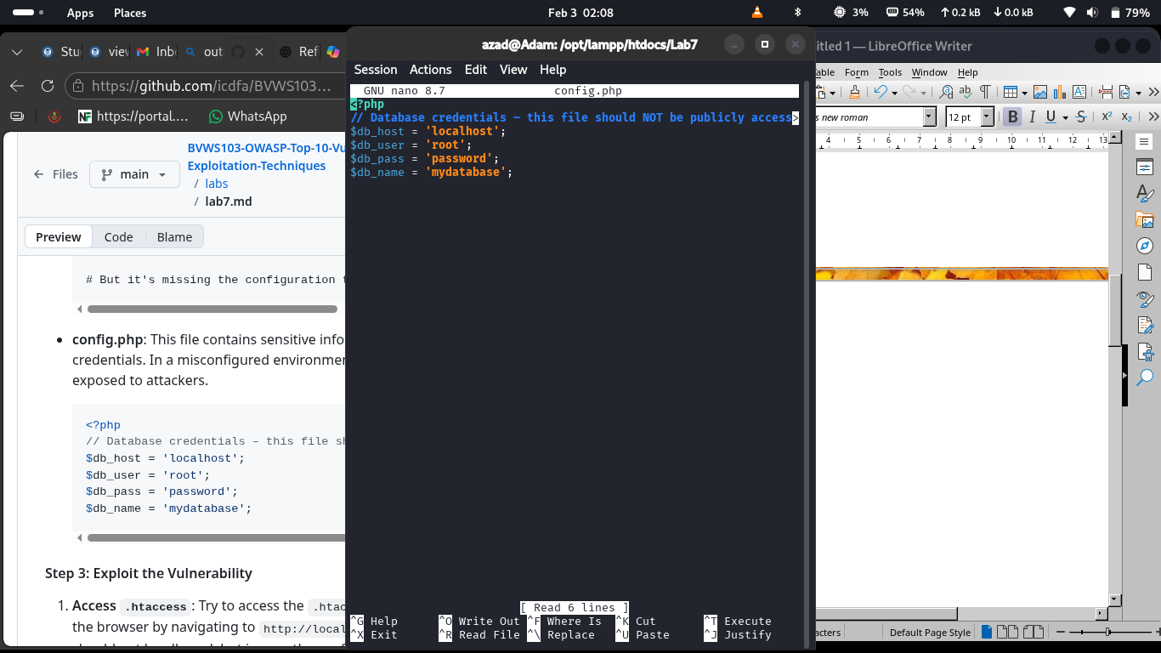

And i then create a database that could sopport my config.php file but will not have any table or column inside
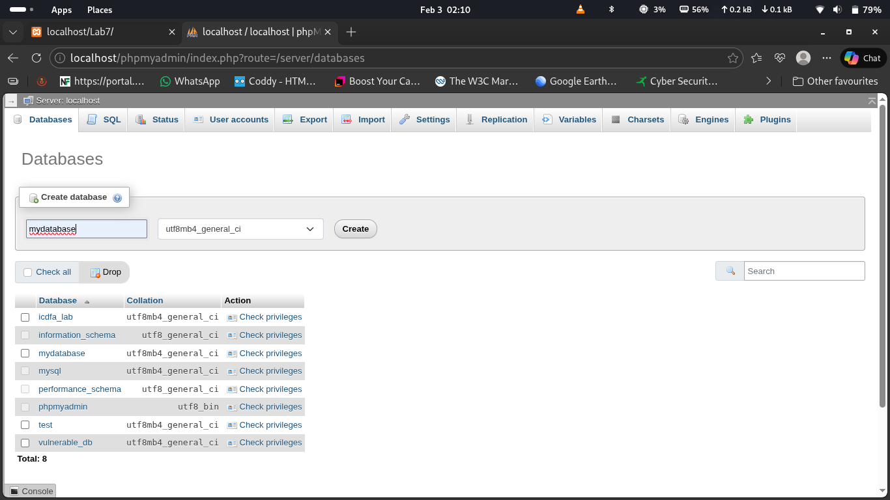

I then test the first perramiter to haave access with but forbidden which is normal
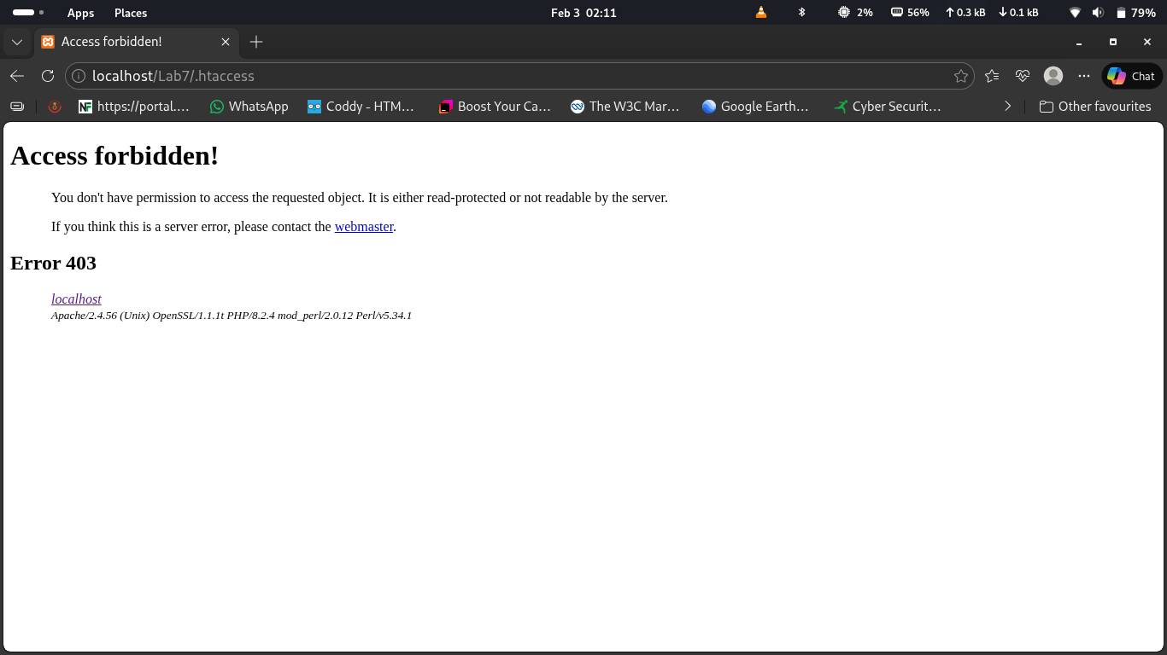

I then try to access the config.php file
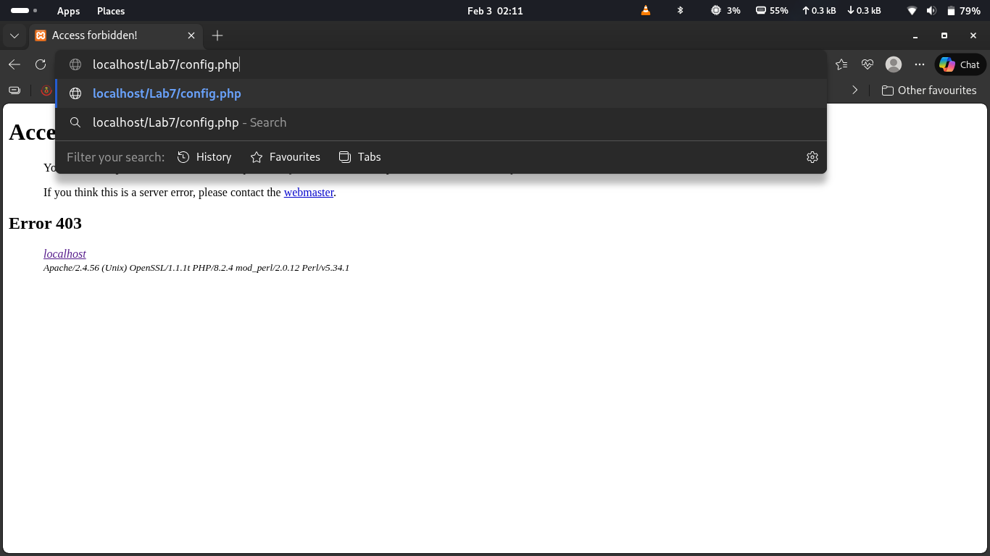

and this show 100% of vulnerability present inthe web page
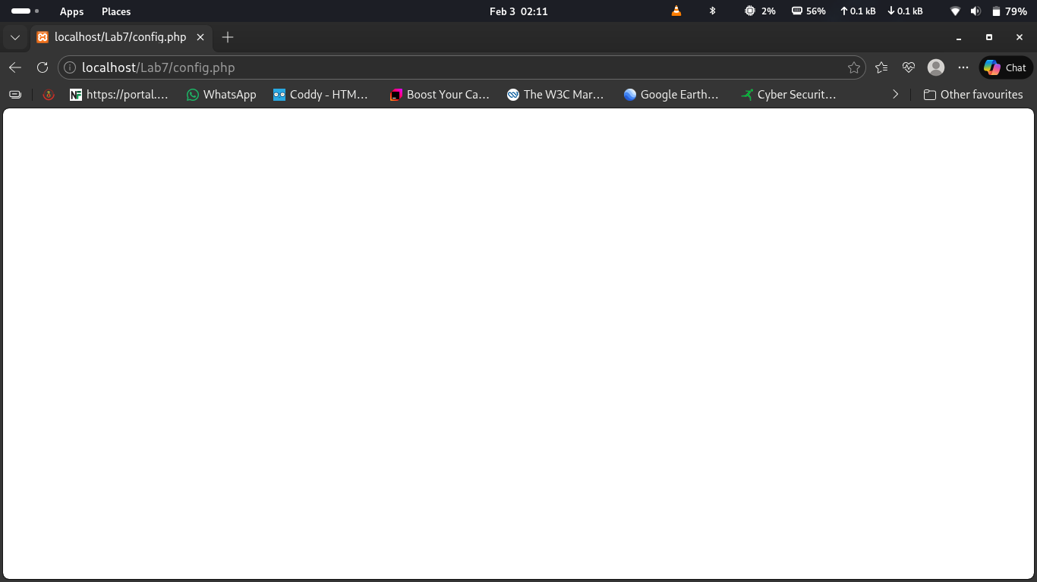

1. What kind of sensitive information can attackers gain by exploiting misconfigurations?
When configuration files such as .htaccess or config.php are publicly accessible, attackers can obtain highly sensitive information that should never be exposed

2. How can access to .htaccess or config.php be restricted to prevent unauthorized access?
Access can be restricted using several security best practices:
- Deny direct web access to sensitive files
- Move sensitive files outside the web root directory
- Set proper file permissions
- Use web server configuration rules.
- Disable directory listing
- Regularly audit server configuration

Task 2: Mitigate Security Misconfiguration
To mitigate this misconfiguration, I prevent access to sensitive files like .htaccess and config.php

The mitigation in .htaccess file
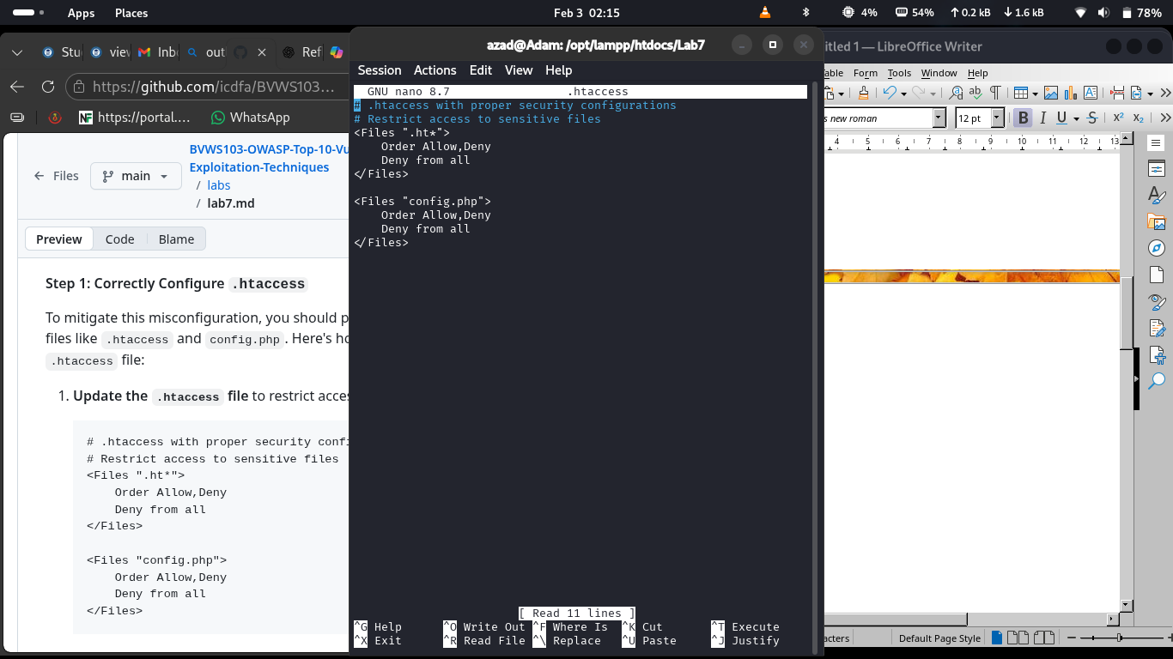
try to access the config.php file
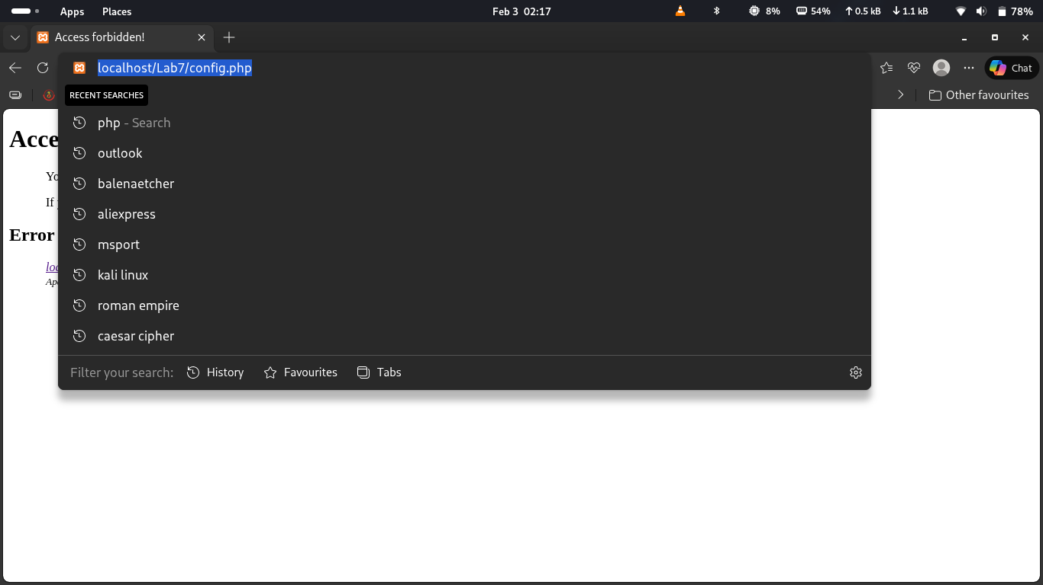
Boom problem solve in this part
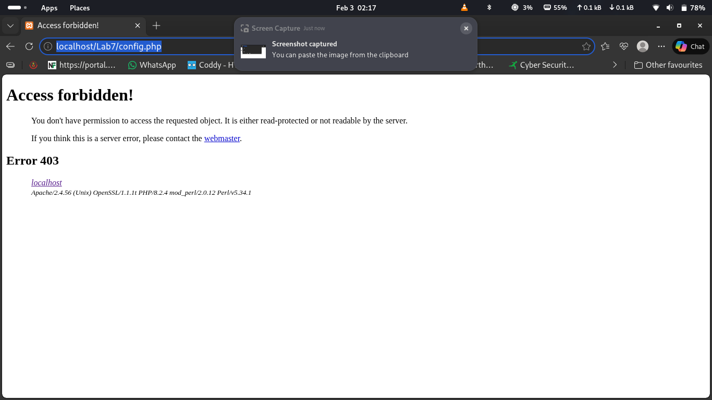

the i try to remodify the URL to add config as a body part of the operation
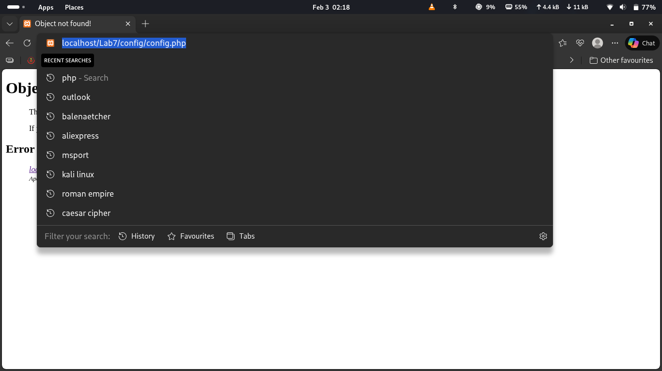

Directly it was also blocked

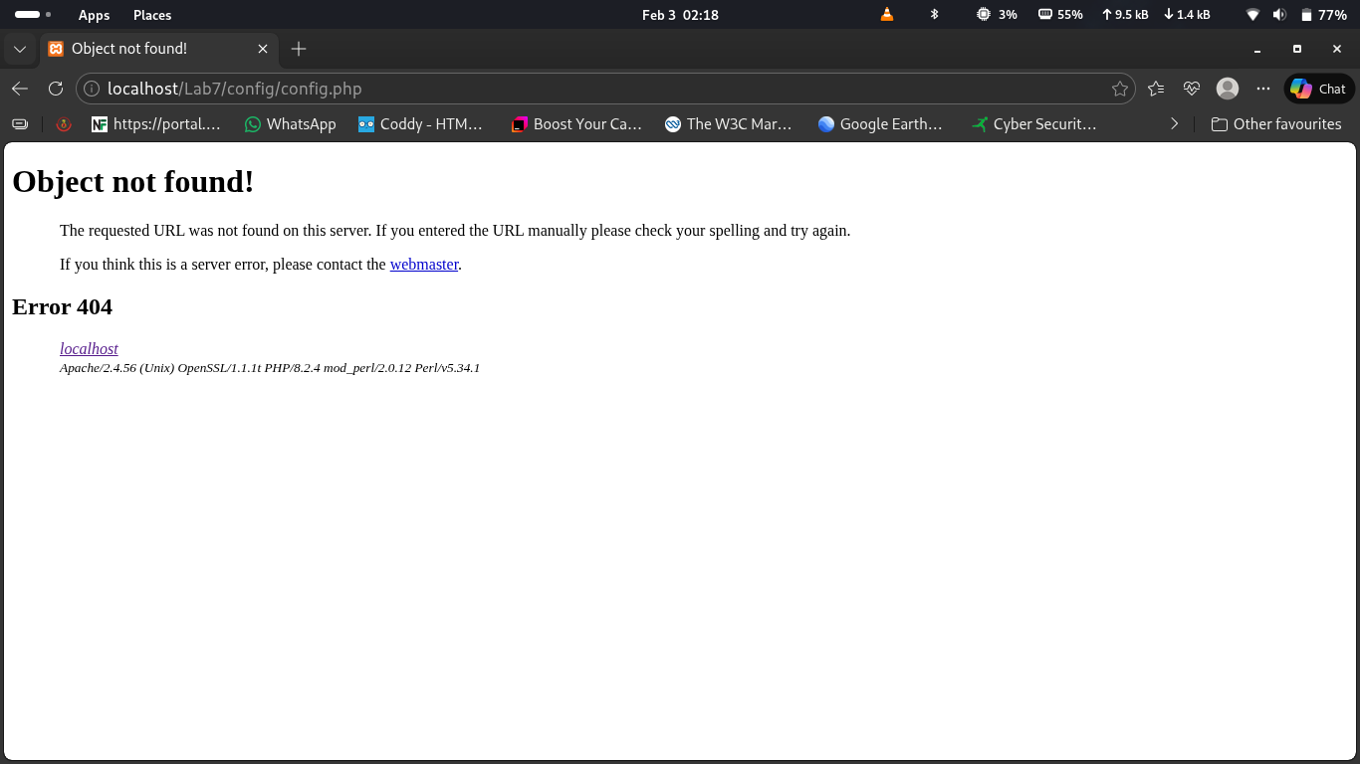

1. How did moving the config.php file out of the public web root improve security?
Moving the config.php file out of the public web root improved security by making it unreachable through a browser URL. Files inside the web root directory can normally be accessed directly by users if they know or guess the filename. Since config.php contains sensitive information like database credentials, exposing it would be dangerous.

2. How do proper file permissions and access control contribute to the overall security of the web application?
Proper file permissions and access control help secure a web application by ensuring that only authorized users and processes can read or modify sensitive files.

conclusion
Security misconfigurations are a common vulnerability in many web applications. By ensuring that files containing sensitive information are properly protected and not accessible from the web, you can significantly reduce the risk of exploitation.

